**SVM( Support Vector Machine )**

SVM Full Form is Support Vector Machine. We use it differentiate the output even if they look correct to machine.

For Ex :- Let us Consume several points of 2 groups. We have to locate a new point in middle of 2 groups and allocate the group name to new point. This is same as KNN but, in svm we try to form best suited line using which we can directly differentiate the point that, it will be in which group.

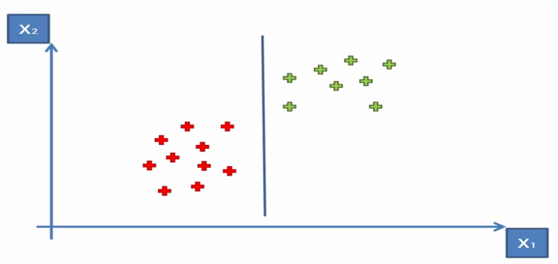 -> Figure 1

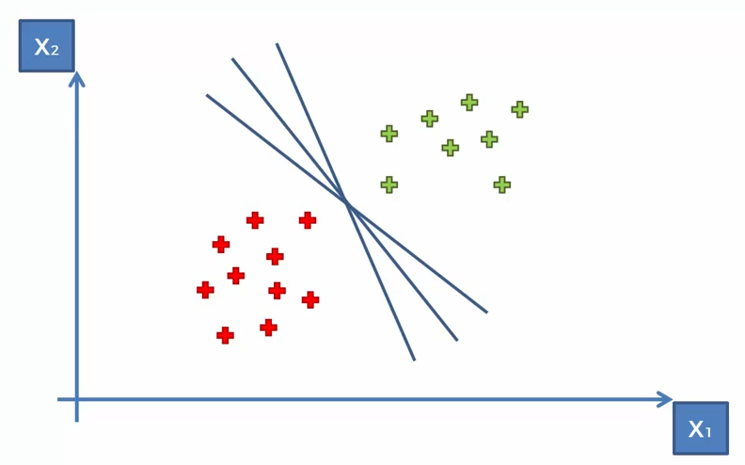 -> Figure 2

By Analyzing above 2 figures( Fig. 1 and Fig. 2 ),

We can divide the two group in ways by plotting several lines in different angles.

Now, the questions is, Which is the best suited Line.

To Identify the best suited line, We will take the most nearest point of red group and most nearest point of green group. Then, we will find the distance of our projected line from red nearest point and same for green nearest point. As following,

Fig 3 :-

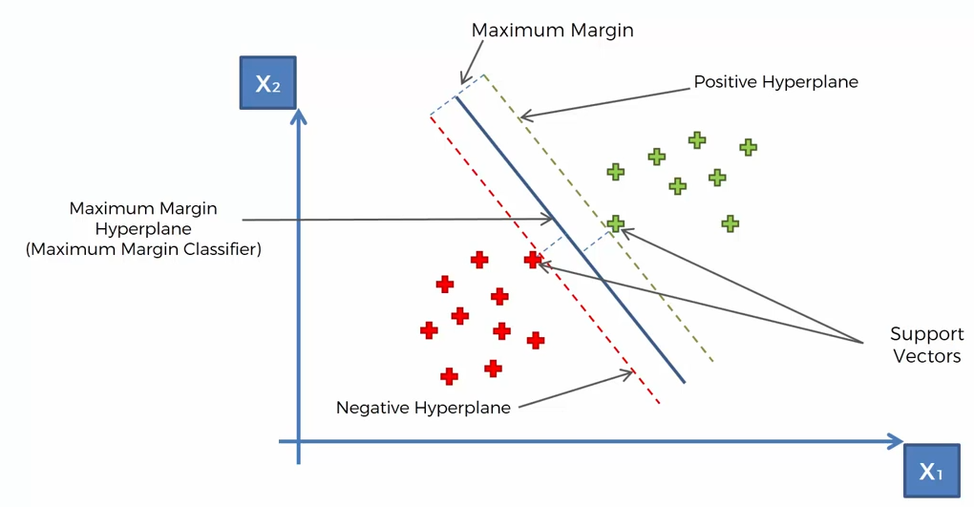

Example 2 :-

Generally we see apple and Orange like following,

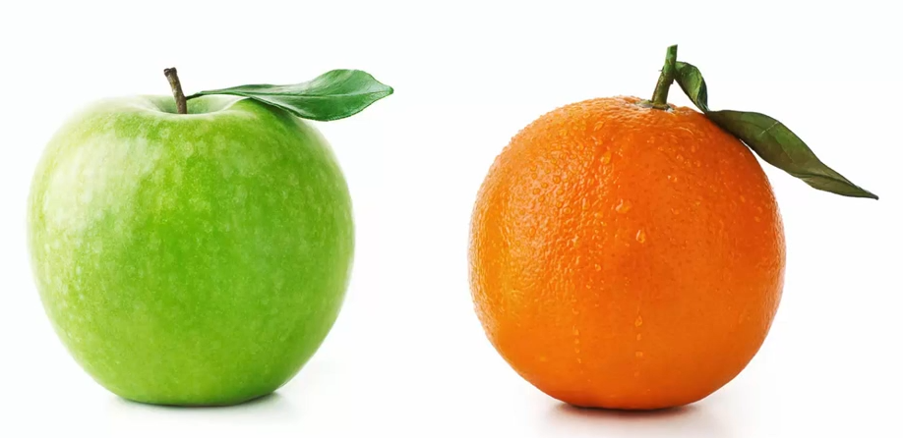

But, if we imagine Apple in Orange Colour and Orange in Green Colour.

Then, Our Machine may get confuse in understanding the perfect Apple and Orange. At this point, we are supposed to apply SVM. Which will help us to find the almost accurate result.